Installation Instructions
- Make sure you have Java version 6 or greater installed. This can be obtained from the Sun website if needed.
- Install the Java Image IO package (version 1.1) from https://jai-imageio.dev.java.net/binary-builds.html
- Go through the configuration information below and work out suitable settings for each item. Decisions you need to make include:
  - Directory locations,
  - Whether you wish to store the full image URL or just the filename in Caisis (see below for more details),
  - Where in Caisis you wish to store the image URL/filename.
- Edit the file “snapshot-creator.properties” to contain the correct directory locations and other properties. See below (section 2) for detailed explanations of the necessary properties. Note that directory paths need to have backslashes escaped – so a backslash appears as \\ the example file shows this so you can follow the examples there.
- Make sure that all the relevant directories and drive mappings have been created.

Configuration

Directories
There are a number of important directories involved in the snapshot creation process. These are also shown on the diagram in Appendix A with the designation A-J to help show where things fit in.

Here are the details of the required directories:

 | Directory | Purpose | Important Info | Usage Notes | Property Key (in properties file)
NDPI Directories
A | NDPI dropbox | Users should drop NDPI files in here when they want them to be “snapshotted” and published to the website. | Only files ending in .ndpi will be processed. Other file types will be ignored. | Users should place new NDPI files in here | ndpi.new.directory
B | Processed NDPI files | NDPI files that have been successfully “snapshotted” are moved into here. |  | No user interaction. Administrator can delete/archive these files if desired to save space. | ndpi.processed.directory
C | Failed NDPI files | NDPI files that could NOT be “snapshotted” are moved here. This should only occur if the file is somehow corrupted or unreadable. |  | Administrator should investigate any failures that occur. | ndpi.failed.directory
Snapshot Directories
D | Snapshots working directory | This is used during processing as a temporary directory for the snapshots |  | Used during processing only. Shouldn’t be touched by users or admins. Directory should remain empty except during processing. | snapshots.holding.directory
E | Snapshots publishing directory | Snapshots that are ready to be published to the website go here. These could come from 2 places:  - From an NDPI file that has just been “snapshotted”  - A user may put a JPG file in here if they wish to replace a “bad” snapshot. | Only files ending in .jpg are processed from here. Other file types are ignored. | Users may place JPG files in here if they wish to replace a snapshot.  Snapshots that are automatically created from NDPI files will also be placed here by the batch script | snapshots.publishing.directory
F | Used snapshots directory | Snapshots that have been published to the website are moved here for archive purposes |  | Users can go here if they wish to view the snapshot JPG files that were created.  Admins may wish to delete/archive these files | snapshots.used.directory
G | Failed snapshots directory | Snapshots that could not be published are moved here. This could be due to the filename not being in the correct format or because the associated record cannot be found in the database. |  | No user interaction  Admins should investigate any failures | snapshots.failed.directory
DeepZoom & Website Directories
H | Deep zoom work directory | This is a temporary work directory used for creating Deep Zoom files |  | No user interaction | deepzoom.work.directory
J | Website publishing directory | This is the directory on the website where the Deep Zoom files should be placed. | This should be wherever your IIS server serves the ABCTB website from. The last part of the path should be snapshot-viewer\snapshots | No user interaction | website.snapshots.publishing.directory

See Appendix B for an example directory structure.

Other Configuration Properties
There are also some other values to configure in snapshot-creator.properties. Some of the values in this file are predefined and should not be updated. Values which do need updating are indicated in the fourth column below.

Property Key | Notes | Value / Sample Value | Needs updating?
output.magnification | The magnification that snapshots are taken at. This has been agreed to be set to 5 with Christine. | 5  (this should not be changed) | No
output.jpeg.quality | JPEG quality of the snapshot. This value has been agree with Christine. | 0.8  (this should not be changed) | No
deepzoom.jpeg.quality | JPEG quality used during DeepZoom processing. Must be set to 1 to avoid further degradation of the image. | 1  (this should not be changed) | No
java.opts | These are the options passed to the java program that creates the snapshot. This should not need to be changed. In the unlikely case of OutOfMemoryErrors occurring, it can be increased. | -Xmx1024M  (this should not be changed) | No
jdbc.driverClass | This specifies the name of the SQLServer JDBC driver to be used. This does not need to be changed | com.microsoft.sqlserver.jdbc.SQLServerDriver  (this should not be changed) | No
jdbc.url | This specifies the JDBC URL of the SQLServer instance for Caisis.  This needs updating with suitable values. For assistance constructing the URL contact Intersect or see here | jdbc:sqlserver://localhost:1433;DATABASE=MyDb | Yes
jdbc.username | SQLServer username for accessing the Caisis database | myuserid | Yes
jdbc.password | Password for the user accessing the Caisis database | mypassword | Yes
caisis.update.sql | This is the SQL that needs to run to insert the image information into the Caisis Database. You will need to decide what column to store it in and what joins are required to link the row to the TB# and Specimen ID  This SQL string MUST contain the following three placeholder values:  :image_location  :tb_number  :specimen_id  These will be extracted from the filename and used to update the correct row. | UPDATE my_table SET image_location = :image_location WHERE tb_ref = :tb_number AND spec_id = :specimen_id | Yes
image.name.pattern | This is the pattern for the value that will be stored in the Caisis DB for the image location. This is flexible enough that you can either insert a full URL or just the file name. See below for more details about this.  This MUST contain the placeholder:  ${filename} | A URL  OR  ${filename} | Yes

Storing full URL or just filename in Caisis
The code is flexible enough that you can store either the full deep zoom URL or just the filename in Caisis. This is up to you to decide what you prefer.

Option 1: full URL
In this case you would specify the “image name pattern” (the last property above) as something like http://example.com/snapshot-viewer/TissueImage.aspx?file=${fileName}
Pros:
- In Caisis and on the public search page, you simply show a link with the URL from the database
Cons
- If your website URL changes in the future, you would have to update all references in the database

Option 2: filename only
In this case you would specify the “image name pattern” (the last property above) as just ${filename}
Pros:
- Caisis DB has no knowledge of full URLs
- If your website URL changes in the future you won’t need to worry about changing anything in the database
Cons
- You will have to build the URL yourself in your code for displaying the link in Caisis and the public search page. You should construct the URL as follows: http://abctb.org.au/abctbNew2/snapshot-viewer/TissueImage.aspx?file=[filename-from-db]

Verification

How to verify adding a new snapshot:

Steps to run:
- Make sure that the software has been installed and the configuration file updated.
- Place a valid NDPI file in directory “A” (see above for directory details).
  - Make sure it is named according to the convention TBRefNum.SpecimenId.ndpi.
- Run the batch script.

Verification steps:
- The original NDPI file has been moved to directory “B”.
- A JPG snapshot has been created and is now in directory “G”.
- Deep zoom files were created and have been published to directory “J”. There should be an XML file and a directory ending in _files for each snapshot.
- The Caisis DB was updated to show that an image is present.
- Check the deep zoom page for the image. Assuming you have set up the directories correctly and that the original file was called “abc.def.ndpi” the URL will be: http://abctb.org.au/abctbNew2/snapshot-viewer/TissueImage.aspx?file=abc.def

How to verify replacing a snapshot
Steps to run:
- Manually create your own snapshot JPG file and place it in directory “E”.
  - Make sure to follow the naming convention TBRefNum.SpecimenId.jpg.
- Run the batch script.

Verification steps:
- The JPG snapshot was moved to directory “G”.
- Deep zoom files were created and have been published to directory “J”. There should be an XML file and a directory ending in _files for each snapshot.
- The Caisis DB was updated to show that an image is present
- Check the deep zoom page for the image. Assuming you have set up the directories correctly and that the original file was called “abc.def.jpg” the URL will be: http://abctb.org.au/abctbNew2/snapshot-viewer/TissueImage.aspx?file=abc.def

Reference Information

Explanation of the contents of the distribution
<Root directory>
- deepzoom [directory] – contains the deepzoom tools which are used to generate the deepzoom files from each JPG image
- dll [directory] – contains the Hamamatsu SDK file which are needed for snapshot creation
- lib [directory] – contains various java libraries needed for the snapshot creation and database update process
- app-context.xml – configuration for the java program
- caisis-updater.jar – the java package for the code that updates the Caisis Database
- snapshot-creator.jar – the java package for the code that makes the snapshots
- run-nightly-batch.bat – the windows batch script that runs the whole process
- log4j.xml – configuration of logging
- snapshot-creator.properties – all the configuration parameters required by the batch process

IMPORTANT NOTE: the only file that should need to be modified is the snapshot-creator.properties. If you wish to modify the batch script please make sure you understand the impact of changing it. The other files and directories are necessary and are expected to be in the directories as shown above. Please don’t modify these.

Tips to help resolve issues and debug
- Review the contents of the output from running the batch file – this should contain detailed information about what has happened and show you at what point things have failed
- View the log file nightly-batch.log (this may be of assistance but the info here should also be in the output from running the batch file
- Make sure all values in the snapshot-creator properties file are set correctly.
- Make sure the configured directories exist and any network drives are mapped.
- Make sure that files being processed have the correct naming convention.
- Make sure that the files being processed correspond to a real record in the Caisis DB. An error will be reported if no row is updated in the DB.

Source code
All source code is included in a separate zip file. Please contact Intersect for assistance with modifying anything.

Appendix A – Overview Diagram
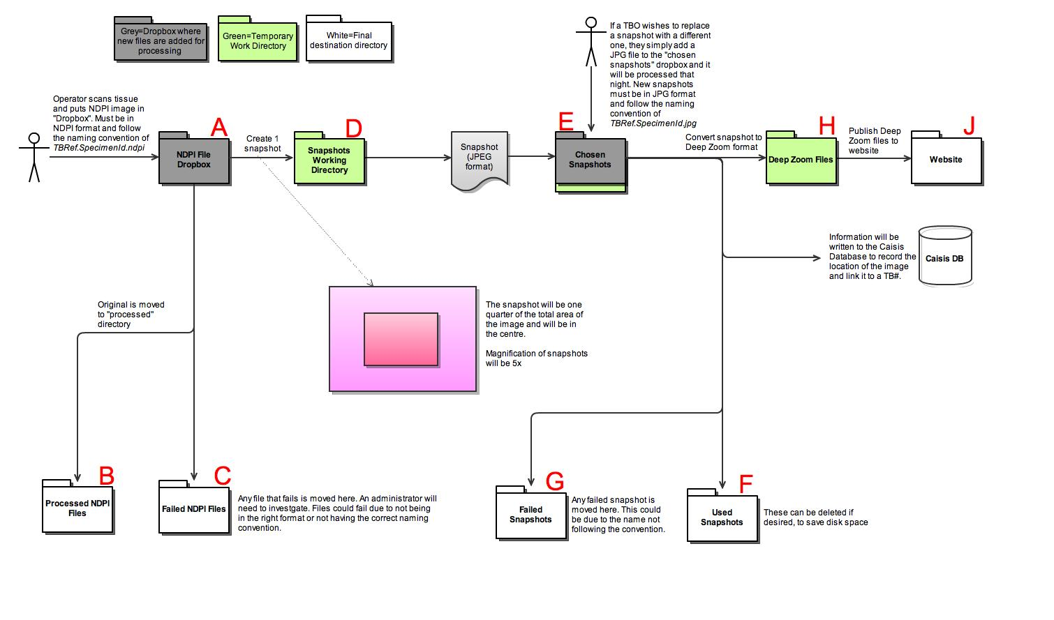

Example Directory Structure

- <root directory>
  - ndpi
    - new
    - processed
    - failed
  - snapshot
    - workdir
    - new
    - processed
    - failed

